Floor Function/Rounded Down
floor(x) return the largest integer that is smaller than or equal to x;
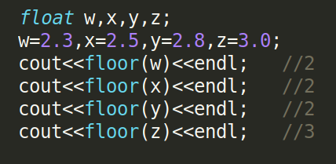

Ceil Function/Rounded Up
ceil(x) returns the smallest integer that is greater than or equal x
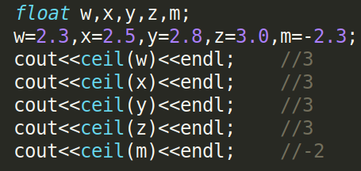

Rounded Function
round(x) return the nearest integer. Or simply just add/subtract 0.5 with the number then print as integer;
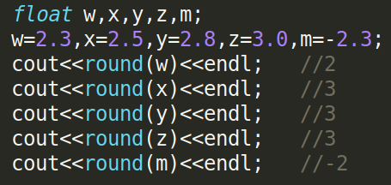

Or
